**User Story Name: Join Lobby**

* Description: **As a** User **I would like** to view the available lobbies for multiplayer **so that** I can join and play against other users.

Acceptance Criteria

* Information about available games are displayed in the activity
* User must be capable of clicking a room and subscribe to it

**Use Case**

Name: Join Lobby

Actor: User

Preconditions:

* Actor is registered as a SkillCourt’s player and
* Actor has SkilCourt app installed in his device

Description <Flow of events>:

|  |  |
| --- | --- |
| Actor Steps | System Steps |
| 1.Actor clicks on the Multiplayer menu option |  |
| 2. Actor clicks on ‘Enter Lobby Button’ |  |
| 3.Actor selects a room to join |  |
|  | 4. System displays the room name and asks for confirmation. |
| 5. Actor clicks ‘Join’ |  |
| 6. Actor is subscribed to room |  |
|  | 7. Information about all subscribed players are loaded into the activity |

**Unit Test**

* Test case ID:
* Description/Summary of Test: Test if the rooms in Firebase are correctly being reflected in the lobby activity and if actor is correctly being subscribed to the room on click.
* Pre-condition: SkillCourt app running.
* Expected Results: Attempts to join lobby, subscribe to room and see player information.
* Actual Result: Joins lobby, subscribes to room and sees player information.
* Status (Fail/Pass): Pass.

**Integration Test**

**Visual User Guide**:

* User opens main menu and chooses Multiplayer

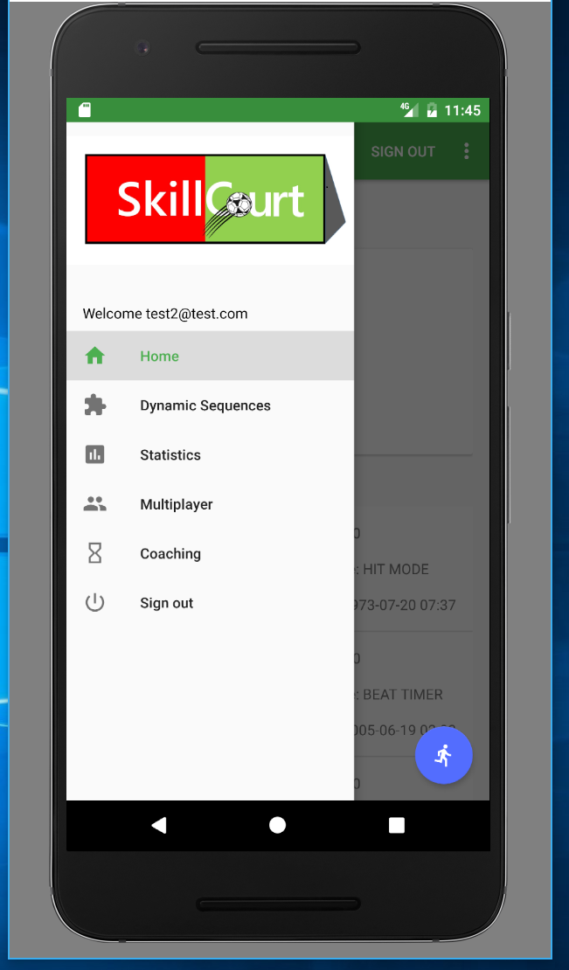

* User selects ‘Enter Lobby’

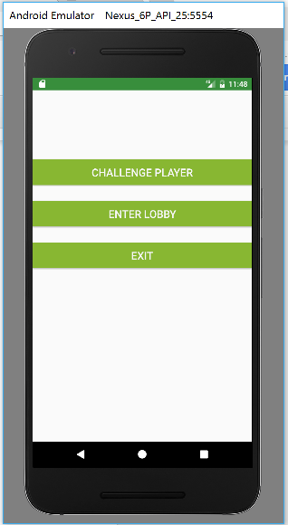

* User selects a room from the lobby list

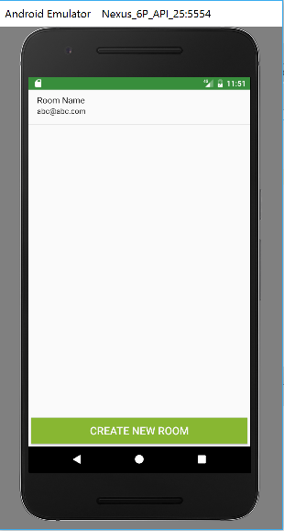

* User confirms their selection

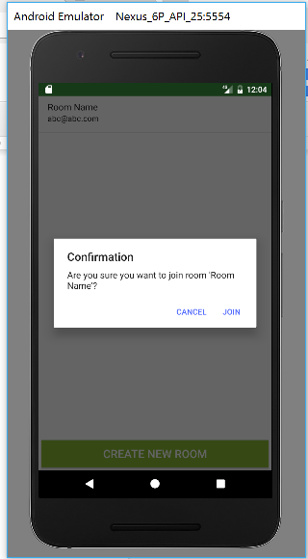

* User is taken to the lobby room

